Custom Hooks:  
  
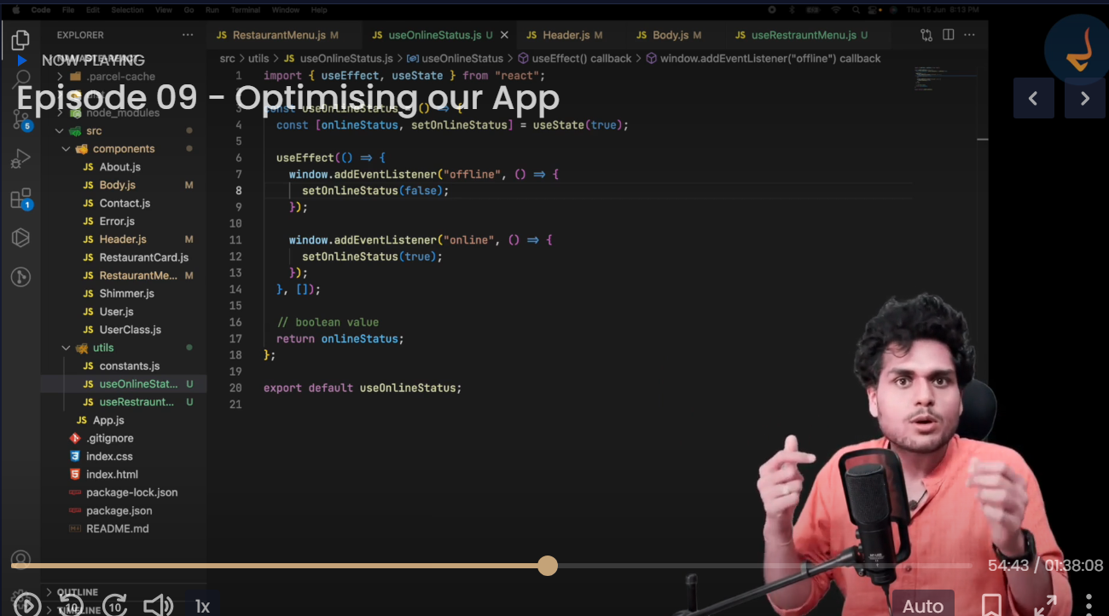

What is code chunking? App splitting? Dynamic Bundling? Lazy Loading   
  
What is lazy in React?

What is suspense in React?